Smart shopping cart
PROJECT Report submitted in partial fulfilment of the requirements for the degree,
BACHELOR OF TECHNOLOGY IN ELECTRICAL ENGINEERING
BY
SHANTI SWAROOP(1501106182) TANMAYA MISHRA(1501106206) SOVAN SAHOO (1501106195)
UNDER THE GUIDANCE OF

PROF.JASMINE HANSDA
DEPARTMENT OF ELECTRICAL ENGINEERING COLLEGE OF ENGINEERING AND TECHNOLOGY,BHUBANESWAR
ACADEMIC YEAR 2018-19
DEPARTMENT OF ELECTRICAL ENGINEERING COLLEGE OF ENGINEERING AND TECHNOLOGY,BHUBANESWAR

CERTIFICATE
This is to certify that the report entitled DESIGN OF SMART SHOPPING CART submitted by Mr. Shanti Swaroop (Regn No.- 1501106182), Mr.Tanmaya Mishra (Regn No.-1501106206), Mr.Sovan Sahoo (Regn No.-1501106195), of the Department of Electrical Engineering, fulfils the requirement of the regulation relating to the nature and standard of the work for the award of the degree of Bachelor of Technology, in Electrical Engineering.

[Dr, MeeraViswavandya ] [Prof Jasmine Hansda]
HEAD OF DEPARTMENT SUPERVISOR
DEPARTMENT OF ELECTRICAL ENGINEERING COLLEGE OF ENGINEERING AND TECHNOLOGY,BHUBANESWAR

DECLARATION
We do hereby declare that, the minor project report entitled, DESIGN OF SMART SHOPPING CART‘is a bonafide work of study carried out by us under the guidance of Ms Jasmine Hansda, Asst. Professor, Department of Electrical Engineering, College of Engineering and Technology, Bhubaneswar. It has been prepared for the fulfilment of the requirements of the degree of ‘Bachelor Of Technology in Electrical Engineering’. The work has not been submitted for any other purpose.

PLACE: [Shanti Swaroop]

DATE:

[Tanmaya Mishra]

[Sovan Sahoo]

ACKNOWLEDGEMENT

We would like to express our gratitude to Ms Jasmine Hansda, Asst. Professor, Department of Electrical Engineering, CET, Bhubaneswar, for his effective guidance throughout our efforts for the successful delivery of the project, seminar and completion of the project. The work could not have been completed without the suggestions and valuable tips given by him. His constant encouragement and regular check on the progress enabled us to complete the work in time.
We would also like to express our gratitude to Dr.MeeraViswavandya, Head Of the Department Of Electrical Engineering, CET Bhubaneswar, for her approval of the project and continuous encouragement to complete the project.
Besides, some technical details enlisted in this report have been taken directly from certain works that have been enlisted in the references provided.
Last but not the least, the timely completion of the project could not have been possible without the moral support extended by our families, friends and the blessings of the Almighty.

Shanti Swaroop Tanmaya Mishra
Sovan Sahoo

ABSTRACT

Aim of the design is to develop a system based on Embedded Microcontroller (8051), which is used for controlling the operations of the E-Cart.Technology today is seeing its heights in all the areas, especially in the area of Embedded Systems. It is true that every electronic gadget that is used in daily life right from a PC keyboard to a refrigerator is an Embedded System. It shows how vastly the technology is expanding. These days Embedded Systems are widely used in domestic as well as industrial purposes in different domains like Communications, Electrical, Instrumentation, and Biomedical etc.

In the current designwe are designing a smart Electronics cart to reduce the rush at any cash counter of shopping mall.Also in this project we are using an Android app that helps to display the total selected products that has been dropped in the cart/ trolley bag. The RFID reader connected at the cart. Each time we drop an item into the cart, the reader receives the signal from each individual product. The connected microcontroller receives signal through the serial communication driver from it. The connected Bluetooth device helps in transferring the data immediately to the paired Smartphone. The Smartphone is pre-installed with a specific android app. This app shows the instant total of the dropped items. As a result there is no need to wait at the counter for a long time for calculation or items crosscheck.
LIST OF ABBREVIATIONS USED

- RFID-Radio Frequency Idenfication
- LCD-Liquid Crystal Display
- I/O-Input/Output
- AC-Alternating Current
- DC-Direct Current
- AIDC-Automatic Identification and Data Capture
- BAP-Battery Assisted Passive
- PRAT-Passive Reader Active Tag
- ARPT-Active Reader Passive
- THF-High Frequency
- UHF-Ultra High Frequency
- EPC-Electronic Product Code
- URL-Uniform Resource Locator
- SOI-Silicon-on-insulator
- RAM-Random Access Memory
- ROM-Read Only Memory
- DSRC-Dedicated Short Range Communication
- ATM-Automated Teller Machine
- CRA-Challenge Response Authentication
- GSA-General Services Administration
- RISC-Reduced Instruction Set Computer
- UART-Universal Asynchronous Receiver/Transmitter
- LED-Light Emitting Diode
- SPP-Serial Port Protocol
- EDR-Enhanced Data Rate
- ISM-Industrial Scientific and Medical
- PAN-Personal Area Network
- FHSS-Frequency Hoping Spread Spectrum
- VCO-Voltage Controlled Oscillator
- PSK-Phase Shift Keying
- IDE-Integrated Development Environment

LIST OF FIGURES
CHAPTER  NUMBER | FIG NO | FIGURE CAPTION | PAGE  NO
2 | 2.1 | TRANSMITTER OF SHOPPING CART | 5
 | 2.2 | RECEIVER OF SHOPPING CART | 6
3 | 3.1 | BLOCK DIAGRAM OF POWER SUPPLY | 7
 | 3.2 | DESIGN OF POWER SUPPLY | 7
 | 3.3 | LM7805 | 8
 | 3.4 | ELECTROLYTIC CAPACITORS | 11
 | 3.5 | COLOUR CODED RESISTORS | 12
 | 3.6 | CHARACTERISTICS OF IDEAL DIODE | 14
 | 3.7 | CHARACTERISTICS OF PRACTICAL DIODE | 14
4 | 4.1 | CIRCUIT CONNECTION | 15
 | 4.2 | RFID TAGS | 17
 | 4.3 | RFID READER | 18
 | 4.4 | BINARY TREE METHOD FOR RFID TAG | 20
 | 4.5 | MICROCONTROLLER | 25
 | 4.6 | BASIC STRUCTURE OF 8051 CORE | 28
 | 4.7 | INTERNAL ARCHITECTURE OF 8051 | 29
 | 4.8 | CONNECTION FOR OSCILLATION AND CLOCK | 30
 | 4.9 | ONE MACHINE CYCLE | 31
 | 4.10 | MEMORY ORGANISATION OF 8051 | 31
 | 4.11 | LED | 32
 | 4.12 | TYPES OF LED | 32
 | 4.13 | LCD DISPLAY | 36
 | 4.14 | DISPLAY | 37
 | 4.15 | PIN CONFIGURATION OF LCD | 38-39
 | 4.16 | BLUETOOTH HC05 MODULE | 39
 | 4.17 | PIN CONFIGURATION OF BLUETOOTH MODULE | 41
5 | 5.1 | BLUETOOTH DONGLE | 45
 | 5.2 | BLOCK DIAGRAM OF FREQUENCY CHOPPING SYSTEM | 48
 | 5.3 | SYNCHRONOUS TRANSMISSION | 56

CHAPTER |  |  |  | TITLE | PAGE NO
 |  |  |  | CERTIFICATE | ii
 |  |  |  | DECLARATION | iii
 |  |  |  | ACKNOWLEDGEMENT | Iv
 |  |  |  | ABSTRACT | V
 |  |  |  | ABBREVIATION | Vi
 |  |  |  | LIST OF FIGURES | Vii
 |  |  |  | TABLE OF CONTENT | Viii
1 |  |  |  | OVERVIEW | 1
 | 1.1 |  |  | INTRODUCTION | 1
 | 1.2 |  |  | MOTIVATION | 1
 | 1.3 |  |  | PROBLEM STATEMENT | 2
 | 1.4 |  |  | LITERATURE REVIEW | 3
2 |  |  |  | WORKING PRINCIPLE OF SMART SHOPPING CART | 4
 | 2.1 |  |  | PROJECT OUTLINE | 4
 | 2.2 |  |  | INTERFACE USED | 5
 | 2.3 |  |  | SOFTWARE USED | 5
 | 2.4 |  |  | BLOCK DIAGRAM | 5
3 |  |  |  | POWER SUPPLY | 7
 | 3.1 |  |  | OVERVIEW | 7
 | 3.2 |  |  | COMPONENT LIST | 8
 |  | 3.2.1 |  | VOLATGE REGULATOR | 8
 |  | 3.2.2 |  | BATTERY | 9
 |  | 3.2.3 |  | CONNECTING WIRES | 9
 |  |  | 3.2.3.1 | ELECTRICAL WIRING SYMBOL | 10
 |  | 3.2.4 |  | CAPACITORS | 10
 |  | 3.2.5 |  | RESISTORS | 12
 |  | 3.2.6 |  | DIODE | 13
 |  |  | 3.2.6.1 | DIODE ELEMENTS | 13
 |  |  | 3.2.6.2 | IDEAL DIODE | 13
 |  |  | 3.2.6.3 | PRACTICAL DIODE | 14
4 |  |  |  | COMPONENTS USED | 15
 | 4.1 |  |  | RADIO FREQUENCY IDENTIFICATION | 16
 |  | 4.1.1 |  | RFID TAGS | 17
 |  | 4.1.2 |  | RFID READER | 18
 |  | 4.1.3 |  | SIGNALLING METHODOLOGY | 19
 |  | 4.1.4 |  | BULK READING | 20
 |  | 4.1.5 |  | MINITURIZATION | 21
 |  | 4.1.6 |  | ADVANTAGES OVER BARCODE TECHNOLOGY | 22
 |  | 4.1.7 |  | COMMON PROBLEMS IN RFID | 23
 | 4.2 |  |  | MICROCONTROLLERS | 25
 |  | 4.2.1 |  | 8051 MICROCONTROLLER | 26
 |  |  | 4.2.1.1 | INTRODUCTION | 27
 |  |  | 4.2.1.2 | INTERNAL ARC OF 8051 | 27
 |  |  | 4.2.1.3 | REGISTERS | 30
 |  |  | 4.2.1.4 | OSCILLATORS AND CLOCK | 30
 |  |  | 4.2.1.5 | MEMORY ORGANISATION | 31
 | 4.3 |  |  | LED | 32
 |  | 4.3.1 |  | TYPES OF LED | 32
 |  | 4.3.2 |  | COLOURS AND MATERIALS OF LED | 33
 |  | 4.3.3 |  | WHITE LEDs | 34
 |  | 4.3.4 |  | ADVANTAGES OF LED | 35
 | 4.4 |  |  | LCD DISPLAY | 36
 | 4.5 |  |  | BLUETOOTH MODULE | 39
 |  | 4.5.1 |  | INTRODUCTION | 39
 |  | 4.5.2 |  | HARDWARE FEATURES | 40
 |  | 4.5.3 |  | SOFTWARE FEATURES | 40
 |  | 4.5.4 |  | PIN DESCRIPTION | 41
 |  | 4.5.5 |  | HOW TO CONNECT BLUETOOTH MODULE | 42
5 |  |  |  | TECHNOLOGY AND SOFTWARE USED | 44
 | 5.1 |  |  | BLUETOOTH TECHNOLOGY | 44
 |  | 5.1.1 |  | COMMON BLUETOOTH PRODUCTS | 44
 |  | 5.1.2 |  | HOW BLUETOOTH WORKS | 46
 |  | 5.1.3 |  | FREQUENCY CHOPPING | 46
 |  | 5.1.4 |  | TECHNICAL OF BLUETOOTH TECHNOLOGY | 47
 |  | 5.1.5 |  | ADVANTAGES OF BT DEVICES | 48
 | 5.2 |  |  | INTRODUCTION TO KIEL | 50
 |  | 5.2.1 |  | CONCEPT OF COMPILERS | 51
 |  | 5.2.2 |  | CONCEPT OF CROSS COMPILERS | 51
 |  | 5.2.3 |  | KIEL C CROSS COMPILER | 52
 |  | 5.2.4 |  | BUILDING AN APPLICATION IN KIEL | 52
 |  | 5.2.5 |  | CREATING OWN APPLICATION IN KIEL | 52
 |  | 5.2.6 |  | DEBUGGING AN APPLICATION | 53
 |  | 5.2.7 |  | BUILDING PROJECT AND CREATING HEX FILES | 53
 |  | 5.2.8 |  | CPU SIMULATION | 54
 |  | 5.2.9 |  | DATABASE SELECTION | 54
 |  | 5.2.10 |  | START DEBUGGING | 54
 |  | 5.2.11 |  | DISASSEMBLY WINDOW | 54
 | 5.3 |  |  | EMBEDDED C | 55
 | 5.4 |  |  | SERIAL COMMUNICATION | 55
 |  | 5.4.1 |  | SYNCHRONOUS TRANSMISSION | 56
 |  | 5.4.2 |  | ASYNCHRONOUS TRANSMISSION | 56
 |  | 5.4.3 |  | BAUD RATE | 57
 |  | 5.4.4 |  | DATA BITS | 57
 |  | 5.4.5 |  | START AND STOP BITS | 57
 |  | 5.4.6 |  | RS232 STANDARD | 57
6 |  |  |  | CODE FOR MICROCONTROLER | 58
7 |  |  |  | HARDWARE TESTING | 61
 | 7.1 |  |  | CONTINUITY TEST | 61
 | 7.2 |  |  | POWER ON TEST | 61
8 |  |  |  | CONCLUSION AND FUTURE SCOPE | 63
 | 8.1 |  |  | CONCLUSION | 63
 | 8.2 |  |  | FUTURE SCOPE | 63
 |  |  |  | REFERENCE | 63

CHAPTER1- OVERVIEW
1.1 INTRODUCTION
Now a days the interest in looking into malls or supermarket is wide increasing among folks. Even if, customers realize numerous difficulties. These difficulties are a unit mentioned below. Most of the day, solely on the tip of purchase customers returns to grasp that the general purchase total is larger than their budget. Then they pay longer to look their desired product and eventually overall looking method becomes longer intense. Thanks to this, many times customers couldn’t get the entire required product and miss out a few things. Another major drawback long-faced by the shoppers is that they need to attend in long queues for asking. Therefore the planned system overcomes of these limitations long-faced by customers in looking malls. At the start of this project, the associate degree application is developed to form looking method simple. This application is intended in such how that it holds data regarding the placement of the product on the market within the mall. The client goes through the things and can choose the required items. After that, the applying displays the rack wise on that the merchandise is placed. Every product in the grocery is labeled with a novel RFID tag. Every handcart is intended or enforced with a microcontroller, LCD, associate degree RFID reader. RFID Reader Reads the product place within the cart. thus as every item is placed, numerous data like product name, worth of the merchandise area unit showed within the liquid crystal display placed on the good cart. Together with the full total is additionally displayed once putt every product within the cart. The full bill quantity can reach the bill counter through Bluetooth technology once we press the button once the purchase is finished. Then the client must pay simply the full quantity in counter. Therefore, this technology permits for fast checkout generates total bill mechanically, and eliminates the various sectional counters and long queues, that area unit in the main reportable because of the most negative aspects of a mall.
1.2 MOTIVATION
Benefit to the customers: This system provides on spot scanning of the product and shows its price details on LCD. This allows customers to compare the total price with the budget in the pocket before billing. Whenever a customer is done with his/her shopping and near to the billing counter, the data from the LCD is going to transfer to the mobile through Bluetooth. By this way, it will save the time of the customers as well.
Benefit to the mall: This system works only for those customers which are having the membership card of the mall. This is implemented by using RFID Tag and RFID Reader. Customers require inserting the membership card which is also a RFID Tag and inserts to a place where RFID Reader is present. Once RFID Reader detects the presence of RFID Tag only then it will allow the shopping trolley or basket to become smart. Otherwise, it will act as a simple trolley.
Reason behind using 8051 microcontroller: We designed the system using the Development Board. It provides complete access to functions of microcontroller or microprocessor like to program the controller, to use the input/output pins, to communicate. The system using 8051 controller is less bulky and it can easily transfer from one place to another. It requires less power supply and we can easily improve the system, if required, because of its easy programming.
Cost efficient and user friendly: Since we designed this system using micro controller and RFID tags hence system requires less cost to design. This system requires less power supply and it displays the total amount to the user so this system is user-friendly.
1.3 PROBLEM STATEMENT
An innovative product with social acceptance is the one that aids the comfort, convenience and the efficiency in everyday life. Purchasing and shopping in a big mall is becoming daily activity in metro cities. There will be rush at these malls on holidays and weekends. People purchase different items and put them in trolley. After completion of the purchases, one needs to go the billing counter for payments .At the billing counter the cashier prepares the bill using bar code reader which is a very time consuming process and results in a long queue at the billing counter.
In this Project, we are implementing a system “RFID based automatic Shopping cart” developed to assist a person in everyday shopping in terms of reduced time spent while purchasing .The main objective of the proposed system is to provide a technology based, low cost, easy scalable and rugged system for making shopping experience free of all hassles of standing in queue, keeping the barcode of every item in light of sight of bar code reader, scanning it and hence payment.
1.4 LITERATURE REVIEW
- Dr. Suryaprasad J in "A Novel Low-Cost Intelligent Shopping Cart" [1] proposed to develop a low-cost intelligent shopping aid that assists the customer to search and select products and inform the customer on any special deals available on the products as they move around in the shopping complex.
- Amine Karmouche in "Aisle-level Scanning for Pervasive RFID-based Shopping Applications" [2] proposed to develop a system that is able to scan dynamic and static products in the shopping space using RFID Reader antennas. Instead of conducting the RFID observations at the level of individual carts, aisle-level scanning is performed.
- Satish Kamble in "Developing a Multitasking Shopping Trolley Based on RFID Technology" [4] proposed to develop a product to assist a person in everyday shopping in terms of reduced time spent while purchasing. The main aim of proposed system is to provide a technology oriented, low-cost, easily scalable, and rugged system for assisting shopping in person.

CHAPTER 2-WORKING PRINCIPLE OF SMART SHOPPING CART
Here the main source of energy is the battery. Battery is used as we need the operation wirelessly. The battery is connected to the power supply unit that energizes each and every devices and components. In the power supply voltage regulators (7812, 7805) are connected to get specific output of 12v and 05v. Capacitors are connected for stabilization, safety and filtration purpose. The connected 8051 microcontroller (AT89S52) is the heart of our project that receives data, processes the data and generates output as per the program done. The connected RFID reader reads RFID card when it is brought nearby. The read data is sent to the microcontroller through serial communication with the help of serial driver (max232). The data after processing is fed to the Bluetooth module that transfers the data to the smart phone.
In the receiver part there is an android app installed in the smart phone. This app is able access the hardware of the smart phone. It receives the data transferred, by the internal blue tooth. The data is displayed on the app. After multiple purchases, the different values of products are being added and displayed on the app. Once purchase is completed, the payment button does all the further work. If button is pressed, payment completes and a random transaction id is being generated.
2.1 PROJECT OUTLINE
- A brief introduction to internal architecture of micro controller.
- An overview of programming of micro controller.
- An overview of Embedded C language.
- An overview of I/O devices.
- An overview of display unit.
- An overview of RFID.
- An overview of Bluetooth & Android App.

2.2 INTERFACES USED
- Serial communication used for downloading the hex code.
- Serial Driver
- RFID Reader
- Bluetooth unit
- Display
- Android App.

2.3 SOFTWARES USED
- A Cross compiler for compiling and linking the code written for AT898C51.
- Serial communication software for downloading code to AT89C51.
- Operating System: Windows 2000 or higher.
- Application program development in Embedded C.

2.4 BLOCK DIAGRAM:
TRANSMITTER
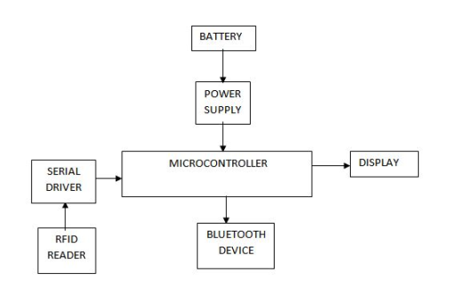
FIG 2.1 TRANSMITTER OF SHOPPING CART

As shown in the above figure 2.1 the components used are:
- RFID reader:
Scans the unique number of the RFID Tags
- Serial driver:
Converts the data in RS 232 level to TTL level used in the micro controller
- Microcontroller:
Contains the user defined program designed according to the project requirements and acts the controller center for the entire system management.
- Battery:
Supplies DC power at 12V and hence eliminates the need for rectifiers.
- Power supply:
Supplies regulated, filtered DC voltage at 5V chopping it down from 12V
- Bluetooth:
Wireless means of communication between microcontroller and user(through android).
- Display:
Uses an LCD module for displaying the commodities purchased and price to the user
RECEIVER
SMART PHONE WITH ANDROID APP

FIG 2.2 RECEIVER
As shown in the above figure 2.2 the components used are :
- Smart Phone with android app:
User interface with microcontroller via an android application outsourced from open source websites

CHAPTER 3 - POWER SUPPLY
3.1 OVERVIEW
All digital circuits require regulated power supply. In this article we are going to learn how to get a regulated positive supply from the mains supply as shown in figure 3.1.

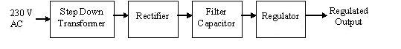
FIG 3.1 BLOCK DIAGRAM OF POWER SUPPLY
In most of our electronic products or projects we need a power supply for converting mains AC voltage to a regulated DC voltage. For making a power supply designing of each and every component is essential. Here I’m going to discuss the designing of regulated 5V Power Supply.
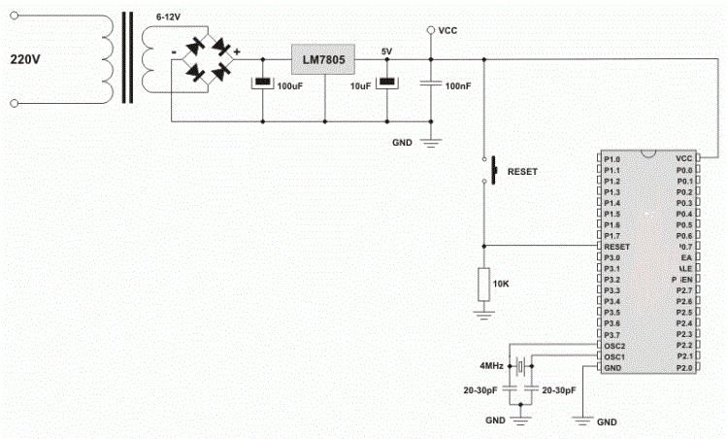
FIG 3.2 DESIGN OF POWER SUPPLY
  - COMPONENT LIST:
The following components are used in power supply
- Voltage regulator
- Battery
- Connecting wires
- Capacitors
- Resistors
- Diodes
3.2.1 VOLTAGE REGULATOR
A Voltage regulator is a device which converts varying input voltage into a constant regulated output voltage. Voltage regulator can be of two types:-
1) Linear Voltage Regulator also called as Resistive Voltage regulator because they dissipate the excessive voltage resistively as heat.
2) Switching Regulators
They regulate the output voltage by switching the Current ON/OFF very rapidly. Since their output is either ON or OFF it dissipates very low power thus achieving higher efficiency as compared to linear voltage regulators. But they are more complex & generate high noise due to their switching action. For low level of output power switching regulators tend to be costly but for higher output wattage they are much cheaper than linear regulators. And 79XX series is for Negative Voltage Regulators. Figure 3.3 shows pin diagram of LM7805
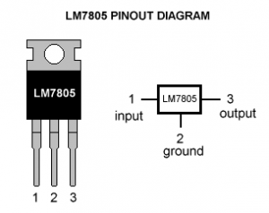
FIG 3.3 LM7805
    - BATTERY
Batteries are a collection of one or more cells whose chemical reactions create a flow of electrons in a circuit. All batteries are made up of three basic components: an anode (the '-' side), a cathode (the '+' side), and some kind of electrolyte (a substance that chemically reacts with the anode and cathode).
When the anode and cathode of a battery is connected to a circuit, a chemical reaction takes place between the anode and the electrolyte. This reaction causes electrons to flow through the circuit and back into the cathode where another chemical reaction takes place. When the material in the cathode or anode is consumed or no longer able to be used in the reaction, the battery is unable to produce electricity. At that point, your battery is "dead."
Batteries that must be thrown away after use are known as primary batteries. Batteries that can be recharged are called secondary batteries.Batteries come in a variety of shapes, sizes, and chemistriesUp until the late 1800s, the electrolyte in batteries was in a liquid state. This made battery transportation a very careful endeavor, and most batteries were never intended to be moved once attached to the circuit.In 1866, Georges Leclanché created a battery using a zinc anode, a manganese dioxide cathode, and an ammonium chloride solution for the electrolyte. While the electrolyte in the Leclanché cell was still a liquid, the battery's chemistry proved to be an important step for the invention of the dry cell.Carl Gassner figured out how to create an electrolyte paste out of ammonium chloride and Plaster of Paris. He patented the new "dry cell" battery in 1886 in Germany.These new dry cells, commonly called "zinc-carbon batteries," were massed produced and proved hugely popular until the late 1950s. While carbon is not used in the chemical reaction, it performs an important role as an electrical conductor in the zinc-carbon battery.
    - CONNECTING WIRES
Connecting wires allows an electrical current to travel from one point on a circuit to another because electricity needs a medium through which it can move. Most of the connecting wires are made up of copper or aluminum. Copper is cheap and good conductivity. Instead of the copper, we can also use silver which has high conductivity but it is too costly to use.

3.2.3.1ELECTRICAL WIRING SYMBOLS
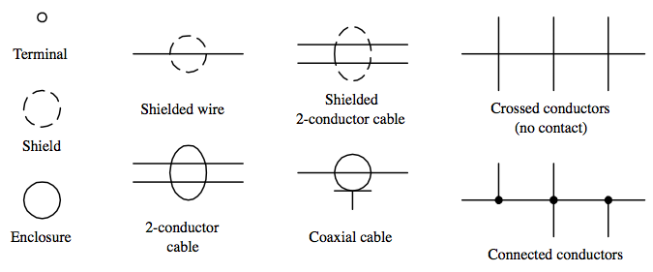
3.2.4 CAPACITORS

A capacitor or condenser is a passive electronic component consisting of a pair of conductors separated by a dielectric. When a voltage potential difference exists between the conductors, an electric field is present in the dielectric. This field stores energy and produces a mechanical force between the plates. The effect is greatest between wide, flat, parallel, narrowly separated conductors.

An ideal capacitor is characterized by a single constant value, capacitance, which is measured in farads. This is the ratio of the electric charge on each conductor to the potential difference between them. In practice, the dielectric between the plates passes a small amount of leakage current. The conductors and leads introduce an equivalent series resistance and the dielectric has an electric field strength limit resulting in a breakdown voltage. Figure 3.4 shows an electrolytic capacitors.

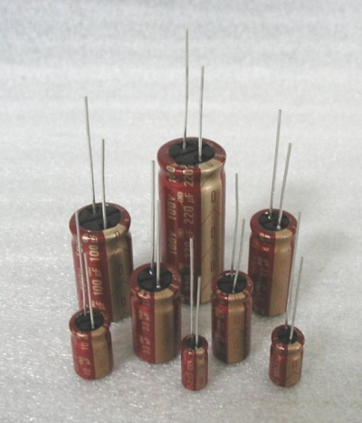
FIG 3.4 ELECTROLYTIC CAPACITOR
The properties of capacitors in a circuit may determine the resonant frequency and quality factor of a resonant circuit, power dissipation and operating frequency in a digital logic circuit, energy capacity in a high-power system, and many other important aspects.

If we go on increasing the value of the filter capacitor then the Ripple will decrease. But then the costing will increase. The value of the Filter capacitor depends on the current consumed by the circuit, the frequency of the waveform & the accepted ripple.
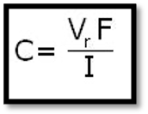
Where,
Vr= accepted ripple voltage.( should not be more than 10% of the voltage)
I= current consumed by the circuit in Amperes.
F= frequency of the waveform. A half wave rectifier has only one peak in one cycle so F=25 Hz
Whereas a full wave rectifier has Two peaks in one cycle so F=100Hz.

3.2.5 RESISTORS

A resistor is a two-terminal electronic component designed to oppose an electric current by producing a voltage drop between its terminals in proportion to the current, that is, in accordance with Ohm's law:
V = IR

Resistors are used as part of electrical networks and electronic circuits. They are extremely commonplace in most electronic equipment. Practical resistors can be made of various compounds and films, as well as resistance wire (wire made of a high-resistivity alloy, such as nickel/chrome).

The primary characteristics of resistors are their resistance and the power they can dissipate. Other characteristics include temperature coefficient, noise, and inductance. Less well-known is critical resistance, the value below which power dissipation limits the maximum permitted current flow, and above which the limit is applied voltage. Critical resistance depends upon the materials constituting the resistor as well as its physical dimensions; it's determined by design as shown in figure 3.10.
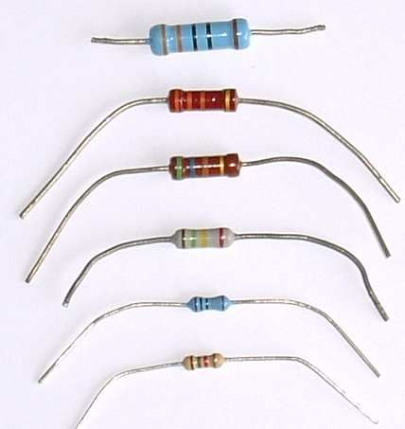
3.5 COLOR CODED RESISTORS

Resistors can be integrated into hybrid and printed circuits, as well as integrated circuits. Size, and position of leads (or terminals) are relevant to equipment designers; resistors must be physically large enough not to overheat when dissipating their power.

3.2.6 DIODE
A diode is simply a PN junction, but its applications are extensive in electronic circuits. Three important characteristics of a diode are, first of all, the forward voltage drop. Under a forward bias condition, this should be about .7 volts. Then there is the reverse voltage drop. In the reverse, when we reverse bias the diode the depletion layer widens and usually, the applied voltages are felt across the diode. Then there is the reverse breakdown voltage. Reverse voltage drop that will reverse current flow and in most cases destroy the diode.
3.2.6.1) DIODE ELEMENTS
A diode has two leads connected to the external circuit. Here we have a little diode here and this would be the two leads. Since the diode behaves differently depending upon forward or reverse bias it is critical to be able to distinguish the leads. The anode connects to the p-type material, this would be the anode right here, this connects to the p material. The cathode connects to the n-type material right here. When you see a diode there is usually a colored band on the diode and the color band indicates the end that is the cathode. One way to remember the designation here is that the arrow always points to the end material. The p material would be here and the arrow was pointing at the end material, which would be the cathode.

3.2.6.2) IDEAL DIODES
In an ideal diode, current flows freely through the device when forward bias, having no resistance. This is ideally what should happen, or what we would want to happen, but this is not what will happen. In an ideal diode, there would be no voltage drop across it when forward biased. All of the source voltages would be dropped across circuit resistors. There'd be no voltage drop across the diode; all of the source voltage would be applied across circuit resistors. In an ideal diode, when reversed bias, it would have infinite resistance, causing zero current flow as shown in figure 3.6.
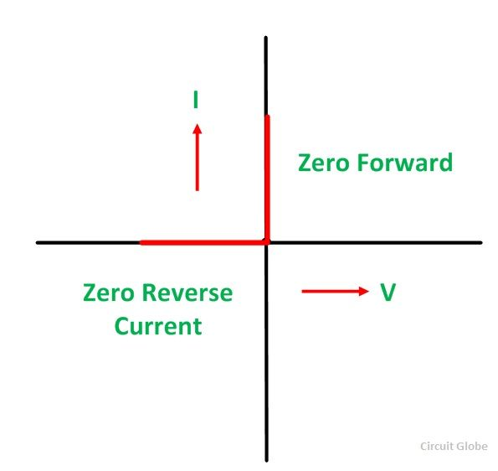
FIG 3.6 CHARACTERISTIC OF IDEAL DIODE

3.2.6.3) PRACTICAL DIODES
Now practical diodes, this is what you'll actually see, a practical diode does offer some resistance to current flow when forward bias. Since there is some resistance there will be some power dissipated when current flows through a forward bias diode. Therefore, there is a practical limit to the amount of current a diode can conduct without damage. A reverse bias diode has very high resistance. Excessive reverse bias can cause the diode to conduct. Figure 3.7 shows characteristics of practical diode
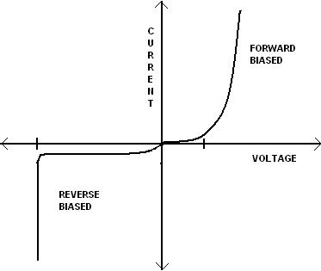
FIG 3.7 CHARACTERISTICS OF PRACTICAL DIODE

CHAPTER 4 - COMPONENTS USED

CIRCUIT DIAGRAM

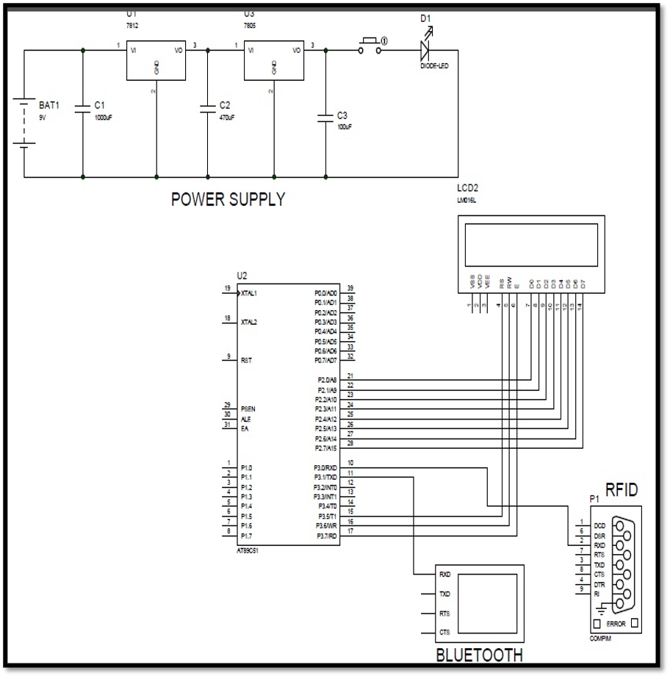

FIG 4.1 CIRCUIT CONNECTIONS

As shown in the above circuit figure 4.1 the components used are the following:

1. RFID

2. MICROCONTROLLER 8051

3. LED

4. LCD

5. BLUETOOTH MODULE

4.1) RADIO FREQUENCY IDENTIFICATION
Radio-frequency identification (RFID) uses electromagnetic fields to automatically identify and track tags attached to objects. The tags contain electronically stored information. Passive tags collect energy from a nearby RFID reader's interrogating radio waves. Active tags have a local power source (such as a battery) and may operate hundreds of meters from the RFID reader. Unlike a barcode, the tag need not be within the line of sight of the reader, so it may be embedded in the tracked object. RFID is one method of automatic identification and data capture (AIDC).
RFID tags are used in many industries. For example, an RFID tag attached to an automobile during production can be used to track its progress through the assembly line; RFID-tagged pharmaceuticals can be tracked through warehouses; and implanting RFID microchips in livestock and pets enables positive identification of animals.
In 2014, the world RFID market was worth US$8.89 billion, up from US$7.77 billion in 2013 and US$6.96 billion in 2012. This figure includes tags, readers, and software/services for RFID cards, labels, fobs, and all other form factors. The market value is expected to rise to US$18.68 billion by 2026.

4.1.1) RFID TAGS
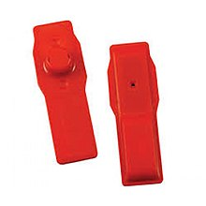
FIG 4.2 RFID HARD TAG 'A3TAG' BY RETAILERS ADVANTAGE
A radio-frequency identification system uses tags, or labels attached to the objects to be identified. Two-way radio transmitter-receivers called interrogators or readers send a signal to the tag and read its response.
RFID tags can be passive, active or battery-assisted passive. An active tag has an on-board battery and periodically transmits its ID signal. A battery-assisted passive (BAP) has a small battery on board and is activated when in the presence of an RFID reader. A passive tag is cheaper and smaller because it has no battery; instead, the tag uses the radio energy transmitted by the reader. However, to operate a passive tag, it must be illuminated with a power level roughly a thousand times stronger than for signal transmission. That makes a difference in interference and in exposure to radiation.Tags may either be read-only, having a factory-assigned serial number that is used as a key into a database, or may be read/write, where object-specific data can be written into the tag by the system user. Field programmable tags may be writing-once, read-multiple; "blank" tags may be written with an electronic product code by the user.
RFID tags contain at least three parts: an integrated circuit that stores and processes information and that modulates and demodulates radio-frequency (RF) signals; a means of collecting DC power from the incident reader signal; and an antenna for receiving and transmitting the signal. The tag information is stored in a non-volatile memory. The RFID tag includes either fixed or programmable logic for processing the transmission and sensor data, respectively.

4.1.2) RFID READER
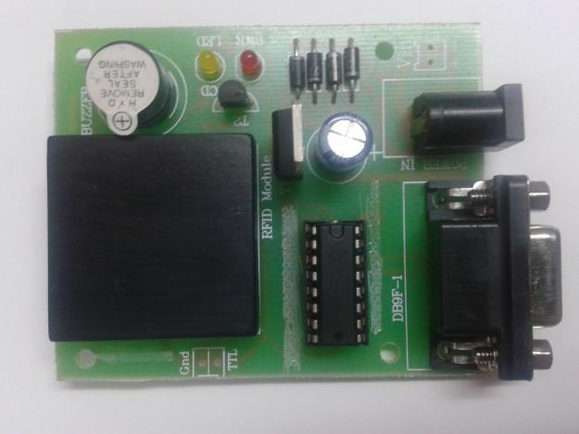
FIG 4.3 RFID READER
An RFID reader transmits an encoded radio signal to interrogate the tag. The RFID tag receives the message and then responds with its identification and other information. This may be only a unique tag serial number, or may be product-related information such as a stock number, lot or batch number, production date, or other specific information. Since tags have individual serial numbers, the RFID system design as shown in figure 4.3 can discriminate among several tags that might be within the range of the RFID reader and read them simultaneously. RFID systems can be classified by the type of tag and reader. A Passive Reader Active Tag (PRAT) system has a passive reader which only receives radio signals from active tags (battery operated, transmit only). The reception range of a PRAT system reader can be adjusted from 1–2,000 feet (0–600 m) allowing flexibility in applications such as asset protection and supervision.
An Active Reader Passive Tag (ARPT) system has an active reader, which transmits interrogator signals and also receives authentication replies from passive tags.An Active Reader Active Tag (ARAT) system uses active tags awoken with an interrogator signal from the active reader. A variation of this system could also use a Battery-Assisted Passive (BAP) tag which acts like a passive tag but has a small battery to power the tag's return reporting signal. Fixed readers are set up to create a specific interrogation zone which can be tightly controlled. This allows a highly defined reading area for when tags go in and out of the interrogation zone. Mobile readers may be hand-held or mounted on carts or vehicles.

4.1.3) SIGNALING METHODOLOGY
Signaling between the reader and the tag is done in several different incompatible ways, depending on the frequency band used by the tag. Tags operating on LF and HF bands are, in terms of radio wavelength, very close to the reader antenna because they are only a small percentage of a wavelength away. In this near field region, the tag is closely coupled electrically with the transmitter in the reader. The tag can modulate the field produced by the reader by changing the electrical loading the tag represents. By switching between lower and higher relative loads, the tag produces a change that the reader can detect. At UHF and higher frequencies, the tag is more than one radio wavelength away from the reader, requiring a different approach. The tag can backscatter a signal. Active tags may contain functionally separated transmitters and receivers, and the tag need not respond on a frequency related to the reader's interrogation signal.
An Electronic Product Code (EPC) is one common type of data stored in a tag. When written into the tag by an RFID printer, the tag contains a 96-bit string of data. The first eight bits are a header which identifies the version of the protocol. The next 28 bits identify the organization that manages the data for this tag; the organization number is assigned by the EPCGlobal consortium. The next 24 bits are an object class, identifying the kind of product; the last 36 bits are a unique serial number for a particular tag. These last two fields are set by the organization that issued the tag. Rather like a URL, the total electronic product code number can be used as a key into a global database to uniquely identify a particular product.
Often more than one tag will respond to a tag reader, for example, many individual products with tags may be shipped in a common box or on a common pallet. Collision detection is important to allow reading of data. Two different types of protocols are used to "singulate" a particular tag, allowing its data to be read in the midst of many similar tags. In a slotted Aloha system, the reader broadcasts an initialization command and a parameter that the tags individually use to pseudo-randomly delay their responses.

When using an "adaptive binary tree" protocol, the reader sends an initialization symbol and then transmits one bit of ID data at a time; only tags with matching bits respond, and eventually only one tag matches the complete ID string.
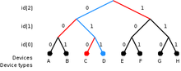
FIG 4.4 AN EXAMPLE OF A BINARY TREE METHOD OF IDENTIFYING AN RFID TAG

4.1.4) BULK READING
"Bulk reading" is a strategy for interrogating multiple tags at the same time, but lacks sufficient precision for inventory control. A group of objects, all of them RFID tagged, are read completely from one single reader position at one time. Bulk reading is a possible use of HF (ISO 18000-3), UHF (ISO 18000-6) and SHF (ISO 18000-4) RFID tags. However, as tags respond strictly sequentially, the time needed for bulk reading grows linearly with the number of labels to be read. This means it takes at least twice as long to read twice as many labels. Due to collision effects, the time required is greater.
A group of tags has to be illuminated by the interrogating signal just like a single tag. This is not a challenge concerning energy, but with respect to visibility; if any of the tags are shielded by other tags, they might not be sufficiently illuminated to return a sufficient response. The response conditions for inductively coupled HF RFID tags and coil antennas in magnetic fields appear better than for UHF or SHF dipole fields, but then distance limits apply and may prevent success.
Under operational conditions, bulk reading is not reliable. Bulk reading can be a rough guide for logistics decisions, but due to a high proportion of reading failures, it is not (yet) suitable for inventory management. However, when a single RFID tag might be seen as not guaranteeing a proper read, a bunch of RFID tags, where at least one will respond, may be a safer approach for detecting a known grouping of objects. In this respect, bulk reading is a fuzzy method for process support. From the perspective of cost and effect, bulk reading is not reported as an economical approach to secure process control in logistics.

4.1.5) MINITURIZATION
RFIDs are easy to conceal or incorporate in other items. For example, in 2009 researchers at Bristol University successfully glued RFID micro-transponders to live ants in order to study their behavior. This trend towards increasingly miniaturized RFIDs is likely to continue as technology advances.
Hitachi holds the record for the smallest RFID chip, at 0.05 mm × 0.05 mm. This is 1/64th the size of the previous record holder, the mu-chip. Manufacture is enabled by using the silicon-on-insulator (SOI) process. These dust-sized chips can store 38-digit numbers using 128-bit Read Only Memory (ROM). A major challenge is the attachment of antennas, thus limiting read range to only millimeters.
A technology similar in theory to bar code identification. With RFID, the electromagnetic or electrostatic coupling in the RF portion of the electromagnetic spectrum is used to transmit signals. An RFID system consists of an antenna and a transceiver, which read the radio frequency and transfer the information to a processing device, and a transponder, or tag, which is an integrated circuit containing the RF circuitry and information to be transmitted.
RFID systems can be used just about anywhere, from clothing tags to missiles to pet tags to food -- anywhere that a unique identification system is needed. The tag can carry information as simple as a pet owners name and address or the cleaning instruction on a sweater to as complex as instructions on how to assemble a car. Some auto manufacturers use RFID systems to move cars through an assembly line. At each successive stage of production, the RFID tag tells the computers what the next step of automated assembly is.
One of the key differences between RFID and bar code technology is RFID eliminates the need for line-of-sight reading that bar coding depends on. Also, RFID scanning can be done at greater distances than bar code scanning. High frequency RFID systems (850 MHz to 950 MHz and 2.4 GHz to 2.5 GHz) offer transmission ranges of more than 90 feet, although wavelengths in the 2.4 GHz range are absorbed by water (the human body) and therefore has limitations. RFID is also called dedicated short range communication (DSRC).
RFID stands for Radio-Frequency Identification. The acronym refers to small electronic devices that consist of a small chip and an antenna. The chip typically is capable of carrying 2,000 bytes of data or less. The RFID device serves the same purpose as a bar code or a magnetic strip on the back of a credit card or ATM card; it provides a unique identifier for that object. And, just as a bar code or magnetic strip must be scanned to get the information, the RFID device must be scanned to retrieve the identifying information.

4.1.6) ADVANTAGES OVER BARCODE TECHNOLOGY

A significant advantage of RFID devices over the others mentioned above is that the RFID device does not need to be positioned precisely relative to the scanner. We're all familiar with the difficulty that store checkout clerks sometimes have in making sure that a barcode can be read. And obviously, credit cards and ATM cards must be swiped through a special reader.

In contrast, RFID devices will work within a few feet (up to 20 feet for high-frequency devices) of the scanner. For example, you could just put all of your groceries or purchases in a bag, and set the bag on the scanner. It would be able to query all of the RFID devices and total your purchase immediately.
RFID technology has been available for more than fifty years. It has only been recently that the ability to manufacture the RFID devices has fallen to the point where they can be used as a "throwaway" inventory or control device. Alien Technologies recently sold 500 million RFID tags to Gillette at a cost of about ten cents per tag.One reason that it has taken so long for RFID to come into common use is the lack of standards in the industry. Most companies invested in RFID technology only use the tags to track items within their control; many of the benefits of RFID come when items are tracked from company to company or from country to country.

4.1.7) COMMON PROBLEMS WITH RFID
Some common problems with RFID are reader collision and tag collision. Reader collision occurs when the signals from two or more readers overlap. The tag is unable to respond to simultaneous queries. Systems must be carefully set up to avoid this problem. Tag collision occurs when many tags are present in a small area; but since the read time is very fast, it is easier for vendors to develop systems that ensure that tags respond one at a time.
1) Data flooding
Not every successful reading of a tag (an observation) is useful for business purposes. A large amount of data may be generated that is not useful for managing inventory or other applications. For example, a customer moving a product from one shelf to another, or a pallet load of articles that passes several readers while being moved in a warehouse, are events that do not produce data that are meaningful to an inventory control system.
Event filtering is required to reduce this data inflow to a meaningful depiction of moving goods passing a threshold. Various concepts have been designed, mainly offered as middleware performing the filtering from noisy and redundant raw data to significant processed data.

2) Global standardization

The frequencies used for UHF RFID in the USA are as of 2007 incompatible with those of Europe or Japan. Furthermore, no emerging standard has yet become as universal as the barcode. To address international trade concerns, it is necessary to use a tag that is operational within all of the international frequency domains.

3) Security concerns
A primary RFID security concern is the illicit tracking of RFID tags. Tags, which are world-readable, pose a risk to both personal location privacy and corporate/military security. Such concerns have been raised with respect to the United States Department of Defense's recent adoption of RFID tags for supply chain management. More generally, privacy organizations have expressed concerns in the context of ongoing efforts to embed electronic product code (EPC) RFID tags in consumer products. This is mostly as result of the fact that RFID tags can be read, and legitimate transactions with readers can be eavesdropped, from non-trivial distances. RFID used in access control, payment and eID (e-passport) systems operate at a shorter range than EPC RFID systems but are also vulnerable to skimming and eavesdropping, albeit at shorter distance.
Unauthorized reading of RFID tags presents a risk to privacy. Unauthorized readers can potentially use RFID information to identify or track packages, consumers, carriers, or the contents of a package. Several prototype systems are being developed to combat unauthorized reading, including RFID signal interruption, as well as the possibility of legislation, and 700 scientific papers have been published on this matter since 2002. There are also concerns that the database structure of Object Naming Service may be susceptible to infiltration, similar to denial-of-service attacks, after the EPCglobal Network ONS root servers were shown to be vulnerable.

4) Health
Microchip–induced tumors have been noted during animal trials.

5) Exploitation
ArsTechnica reported in March 2006 an RFID buffer overflow bug that could infect airport terminal RFID databases for baggage, and also passport databases to obtain confidential information on the passport holder.

6) Passports
In an effort to standardize and make it easier to process passports, several countries have implemented RFID in passports, despite security and privacy issues. The encryption on UK chips was broken in under 48 hours. Since that incident, further efforts have allowed researchers to clone passport data while the passport is being mailed to its owner. Where a criminal used to need to secretly open and then reseal the envelope, now it can be done without detection, adding some degree of insecurity to the passport system.

7) Shielding
In an effort to prevent the passive “skimming” of RFID-enabled cards or passports, the U.S. General Services Administration (GSA) issued a set of test procedures for evaluating electromagnetically opaque sleeves.^{[97]} For shielding products to be in compliance with FIPS-201 guidelines, they must meet or exceed this published standard. Shielding products currently evaluated as FIPS-201 compliant are listed on the website of the U.S. CIO's FIPS-201 Evaluation Program. The United States government requires that when new ID cards are issued, they must be delivered with an approved shielding sleeve or holder.

8) Privacy
The use of RFID has engendered considerable controversy and even product boycotts by privacy advocates. Consumer privacy experts Katherine Albrecht and Liz McIntyre are two prominent critics of the "spy chip" technology. The two main privacy concerns regarding RFID are:
- Since the owner of an item will not necessarily be aware of the presence of an RFID tag and the tag can be read at a distance without the knowledge of the individual, it becomes possible to gather sensitive data about an individual without consent.
- If a tagged item is paid for by credit card or in conjunction with use of a loyalty card, then it would be possible to indirectly deduce the identity of the purchaser by reading the globally unique ID of that item (contained in the RFID tag). This is only true if the person doing the watching also had access to the loyalty card data and the credit card data, and the person with the equipment knows where the purchaser is going to be.
4.2 MICROCONTROLLERS

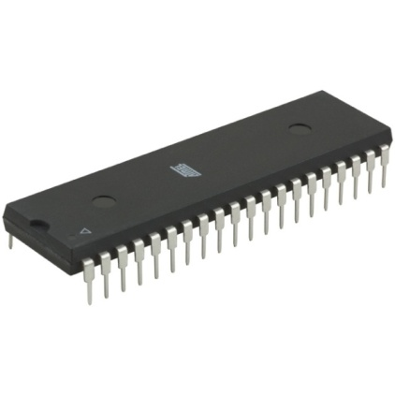
FIG 4.5 MICROCONTROLLER
Microcontrollers, as the name suggests, are small controllers. They are like single chip computers that are often embedded into other systems to function as processing/controlling unit. For example, the remote control you are using probably has microcontrollers inside that do decoding and other controlling functions. They are also used in automobiles, washing machines, microwave ovens, toys etc, where automation is needed.
The key features of microcontrollers include:
- High Integration of Functionality
Microcontrollers sometimes are called single-chip computers because they have on-chip memory and I/O circuitry and other circuitries that enable them to function as small standalone computers without other supporting circuitry.
- Field Programmability, Flexibility
Microcontrollers often use EEPROM or EPROM as their storage device to allow field programmability so they are flexible to use. Once the program is tested to be correct then large quantities of microcontrollers can be programmed to be used in embedded systems.
- Easy to Use
Assembly language is often used in microcontrollers and since they usually follow a RISC architecture, the instruction set is small. The development package of microcontrollers often includes an assembler, a simulator, a programmer to "burn" the chip and a demonstration board. Some packages include a high level language compiler such as a C compiler and more sophisticated libraries.
4.2.1) 8051 MICROCONTROLLER:
Despite it’s relatively old age, the 8051 is one of the most popular microcontrollers in use today. Many derivative microcontrollers have since been developed that are based on--and compatible with`--the 8051. Thus, the ability to program an 8051 is an important skill for anyone who plans to develop products that will take advantage of microcontrollers.

4.2.1.1) Introduction
The 8051 is the original member of the MCS-51family, and is the core for all MCS-51 devices. The features of the 8051 core are:
- 8-bit CPU optimized for control applications
- Extensive Boolean processing (single-bit logic) capabilities
- 64K program memory address space
- 64K data memory address space
- 4K bytes of on-chip program memory
- 128 bytes of on-chip data RAM
- 32bidirectional and individually addressable I/O lines
- Two 16- bit timer/counter Full duplex UART
- 6- source / 5 vector interrupt structure with two priority levels
- On-chip clock oscillator

4.2.1.2) Internal architecture of 8051(REFER FIGURE 5.5)
- It consists of
- 8 bit ALU, with two registers A & B
- 11 bit Program Counter & Data Pointer
- 8 bit Program Status Word
- 8bit Stack Pointer
- 128 bytes Internal RAM
    - 4 register banks, each containing 8 registers.
    - 16 bytes, which may be addressed at bit level.
    - 80 bytes of general purpose data memory.
      - Internal ROM / EPROM / Flash memory of 4KB
      - Can be extended separate 64KB address space for data & code memory.
      - 32 discrete I/O pins, grouped as four 8 bit ports.
      - Full Duplex UART.
      - Two l6 bit timer / counter - T0 & T1
      - Two external & three internal interrupt sources
      - Control registers –TCON, TMOD, SCON, PCON, and IP & IE
      - Oscillator & clock circuits

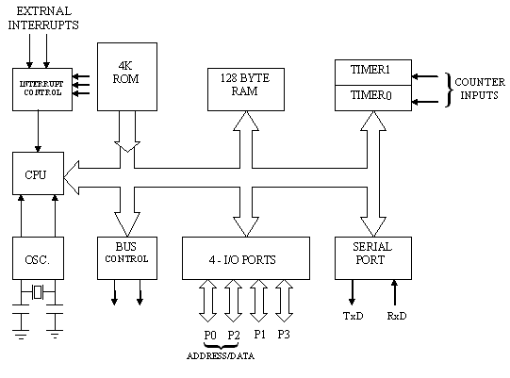
FIG 4.6 THE BASIC ARCHITECTURAL STRUCTURE OF THIS 8051 CORE.

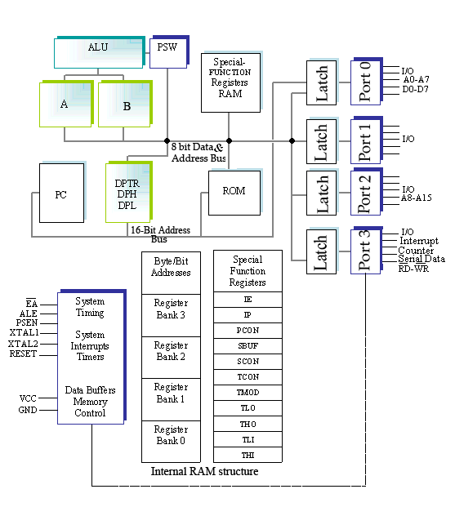
FIG 4.7 INTERNAL ARCHITECTURE OF 8051

4.2.1.3) REGISTERS:

  - 8051 has 34 general purpose or working registers. Two of them A & B, hold results of many instructions,
  - The other 32 Reg. arranged as a part of internal RAM in four banks RBO-RB3.
  - Carry flag is set whenever there is carry out from MSB. This flag is after 8 bit ADD/ SUB operation.
  - It can also be set to 1 or 0 directly using SETB C or CLR C.
  - Auxiliary carry: If there is a carry from D3 to D4 position during Add/sub operation, this bit will set. Otherwise, it is cleared. This flag is used for BCD operations.
  - Parity Flag reflects the number of 1’s in ‘A’. If ‘A’ contains an odd number of 1’s, then P=1. Therefore P=0, if A has an even number of 1’s.
  - Over Flow Flag: This flag is set whenever the result of a signed number operation is too large to be accommodated in 7bits, causing the Higher order bit to over flow into the Sign Bit.
4.2.1.4) Oscillator & Clock
- 8051 has on Chip Oscillator but needs an external clock to run it. A Quartz crystal oscillator is connected to XTAL2 & XTAL1.C1 &C2 are also connected as shown below in figure 5.5.
C1= C2= 30pf (typical)
Crystal oscillator=1to 16 MHz
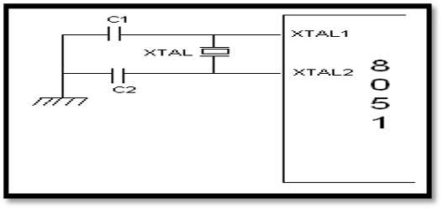

FIG 4.8 CONNECTION FOR OSCILLATION AND CLOCK
- Each Machine Cycle is made up of 6 states as shown in figure 4.9. A state is basic time interval for discrete operations of µcontroller such as opcode fetch, decode an opcode, Execute an opcode. Two oscillator pulses define a state.
- Program Instructions may require 1/2/3/4 machine cycles, depending on its type.
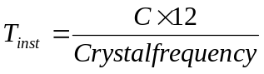
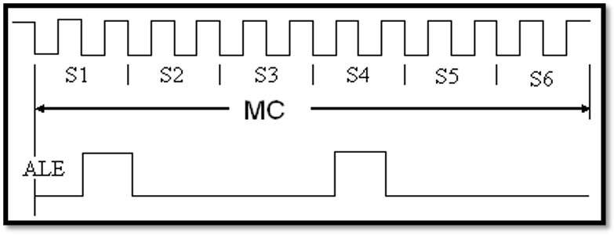

FIG 4.9 ONE MACHINE CYCLE
4.2.1.5) MEMORY ORGANIZATION
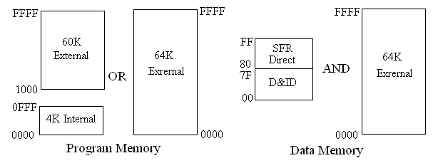

FIG 4.10 MEMORY ORGANIZATION OF 8051
- According to above figure 4.10 8051 has separate address spaces for program memory and data memory.
- Program memory can be up to 64KB, lower 4KB may reside ON-CHIP.
- 8051 can address up to 64KB of data memory.
- It has 128bytes of ON-CHIP RAM and SFR (128B).
- The lower 128bytes can be accessed either by direct addressing or indirect addressing.
4.3. LED
LEDs are semiconductor devices. Like transistors, and other diodes, LEDs are made out of silicon. What makes an LED give off light are the small amounts of chemical impurities that are added to the silicon, such as gallium, arsenide, indium, and nitride.When current passes through the LED, it emits photons as a byproduct. Normal light bulbs produce light by heating a metal filament until it is white hot as shown in figure 5.8. LEDs produce photons directly and not via heat, they are far more efficient than incandescent bulbs.


FIG 4.11 TYPICAL LED
Not long ago LEDs were only bright enough to be used as indicators on dashboards or electronic equipment. But recent advances have made LEDs bright enough to rival traditional lighting technologies. Modern LEDs can replace incandescent bulbs in almost any application.

4.3.1) TYPES OF LED’S
LEDs are produced in an array of shapes and sizes as shown in figure 6.2. The 5 mm cylindrical package is the most common, estimated at 80% of world production. The color of the plastic lens is often the same as the actual color of light emitted, but not always. For instance, purple plastic is often used for infrared LEDs, and most blue devices have clear housings. There are also LEDs in extremely tiny packages, such as those found on blinkers and on cell phone keypads. The main types of LEDs are miniature, high power devices and custom designs such as alphanumeric or multi-color.
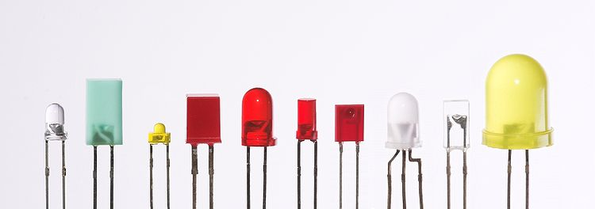
FIG 4.12 DIFFERENT TYPES OF LED’S

4.3.2) COLORS AND MATERIALS OF LED

Conventional LED’S are made from a variety of inorganic semiconductor materials, the following table shows the available colours with wavelength range, voltage drop and material.So how does a light emitting diode get its colour. Unlike normal signal diodes which are made for detection or power rectification, and which are made from either Germanium or Silicon semiconductor materials, Light Emitting Diodes are made from exotic semiconductor compounds such as Gallium Arsenide (GaAs), Gallium Phosphide (GaP), Gallium Arsenide Phosphide (GaAsP), Silicon Carbide (SiC) or Gallium Indium Nitride (GaInN) all mixed together at different ratios to produce a distinct wavelength of colour.Different LED compounds emit light in specific regions of the visible light spectrum and therefore produce different intensity levels. The exact choice of the semiconductor material used will determine the overall wavelength of the photon light emissions and therefore the resulting colour of the light emitted.Thus, the actual colour of a light emitting diode is determined by the wavelength of the light emitted, which in turn is determined by the actual semiconductor compound used in forming the PN junction during manufacture.Therefore the colour of the light emitted by an LED is NOT determined by the colouring of the LED’s plastic body although these are slightly coloured to both enhance the light output and to indicate its colour when its not being illuminated by an electrical supply.Recently developed blue and white coloured LEDs are also available but these tend to be much more expensive than the normal standard colours due to the production costs of mixing together two or more complementary colours at an exact ratio within the semiconductor compound and also by injecting nitrogen atoms into the crystal structure during the doping process.
- Gallium Arsenide (GaAs) – infra-red
- Gallium Arsenide Phosphide (GaAsP) – red to infra-red, orange
- Aluminium Gallium Arsenide Phosphide (AlGaAsP) – high-brightness red, orange-red, orange, and yellow
- Gallium Phosphide (GaP) – red, yellow and green
- Aluminium Gallium Phosphide (AlGaP) – green
- Gallium Nitride (GaN) – green, emerald green
- Gallium Indium Nitride (GaInN) – near ultraviolet, bluish-green and blue
- Silicon Carbide (SiC) – blue as a substrate
- Zinc Selenide (ZnSe) – blue
- Aluminium Gallium Nitride (AlGaN) – ultraviolet

4.3.3) WHITE LED’S
Light Emitting Diodes (LED) have recently become available that are white and bright, so bright that they seriously compete with incandescent lamps in lighting applications. They are still pretty expensive as compared to a GOW lamp but draw much less current and project a fairly well focused beam.

The diode in the photo came with a neat little reflector that tends to sharpen the beam a little but doesn't seem to add much to the overall intensity. When run within their ratings, they are more reliable than lamps as well. Red LEDs are now being used in automotive and truck tail lights and in red traffic signal lights. You will be able to detect them because they look like an array of point sources and they go on and off instantly as compared to conventional incandescent lamps.

LEDs are monochromatic (one color) devices. The color is determined by the band gap of the semiconductor used to make them. Red, green, yellow and blue LEDs are fairly common. White light contains all colors and cannot be directly created by a single LED. The most common form of "white" LED really isn't white. It is a Gallium Nitride blue LED coated with a phosphor that, when excited by the blue LED light, emits a broad range spectrum that in addition to the blue emission, makes a fairly white light.

There is a claim that these white LED's have a limited life. After 1000 hours or so of operation, they tend to yellow and dim to some extent. Running the LEDs at more than their rated current will certainly accelerate this process.There are two primary ways of producing high intensity white-light using LED’S. One is to use individual LED’S that emit three primary colors’—red, green, and blue—and then mix all the colours to form white light. The other is to use a phosphor material to convert monochromatic light from a blue or UV LED to broad-spectrum white light, much in the same way a fluorescent light bulb works. Due to metamerism, it is possible to have quite different spectra that appear white.
4.3.4) ADVANTAGES OF LEDs

- Efficiency:
LEDs produce more light per watt than incandescent bulbs; this is useful in battery powered or energy-saving devices.
- Size:
LEDs can be very small (smaller than 2 mm²) and are easily populated onto printed circuit boards.
- On/Off time:
LEDs light up very quickly. A typical red indicator LED will achieve full brightness in microseconds. LEDs used in communications devices can have even faster response times.
- Cycling:
LEDs are ideal for use in applications that are subject to frequent on-off cycling, unlike fluorescent lamps that burn out more quickly when cycled frequently, or HID lamps that require a long time before restarting.
- Cool light:
In contrast to most light sources, LEDs radiate very little heat in the form of IR that can cause damage to sensitive objects or fabrics. Wasted energy is dispersed as heat through the base of the LED.

- Lifetime:
LEDs can have a relatively long useful life. One report estimates 35,000 to 50,000 hours of useful life, though time to complete failure may be longer.
- No Toxicity:
LEDs do not contain mercury, unlike fluorescent lamps.
4.3.5) DISADVANTAGES OF LEDs
- High price:
LEDs are currently more expensive, price per lumen, on an initial capital cost basis, than most conventional lighting technologies.

- Temperature dependence:
LED performance largely depends on the ambient temperature of the operating environment. Over-driving the LED in high ambient temperatures may result in overheating of the LED package, eventually leading to device failure.
- Voltage sensitivity:
LEDs must be supplied with the voltage above the threshold and a current below the rating. This can involve series resistors or current-regulated power supplies.
- Area light source:
LEDs do not approximate a “point source” of light, but rather a lambertian distribution. So LEDs are difficult to use in applications requiring a spherical light field. LEDs are not capable of providing divergence below a few degrees. This is contrasted with lasers, which can produce beams with divergences of 0.2 degrees or less.
- Blue Hazard:
There is increasing concern that blue LEDs and cool-white LEDs are now capable of exceeding safe limits of the so-called blue-light hazard as defined in eye safety.
4.4 LCD DISPLAY
Liquid crystal display (LCD) has material which combines the properties of both liquid and crystals. They have a temperature range within which the molecules are almost as mobile as they would be in a liquid, but are grouped together in an order form similar to a crystal.

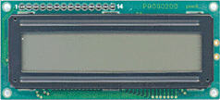
FIG 4.13 LCD DISPLAY
More microcontroller devices are using 'smart LCD' displays to output visual information as shown in figure 5.10. The following discussion covers the connection of a Hitachi LCD display to a PIC microcontroller. LCD displays designed around Hitachi's LCD HD44780 module, are inexpensive, easy to use, and it is even possible to produce a readout using the 8 x 80 pixels of the display. Hitachi LCD displays have a standard ASCII set of characters plus Japanese, Greek and mathematical symbols.For an 8-bit data bus, the display requires a +5V supply plus 11 I/O lines. For a 4-bit data bus it only requires the supply lines plus seven extra lines. When the LCD display is not enabled, data lines are tri-state which means they are in a state of high impedance (as though they are disconnected) and this means they do not interfere with the operation of the microcontroller when the display is not being addressed.
Reading data from the LCD is done in the same way, but control line R/W has to be high. When we send a high to the LCD, it will reset and wait for instructions. Typical instructions sent to LCD display after a reset are: turning on a display, turning on a cursor and writing characters from left to right. When the LCD is initialized, it is ready to continue receiving data or instructions. If it receives a character, it will write it on the display and move the cursor one space to the right.

The Cursor marks the next location where a character will be written. When we want to write a string of characters, first we need to set up the starting address, and then send one character at a time. Characters that can be shown on the display are stored in data display (DD) RAM. The size of DDRAM is 80 bytes.The LCD display also possesses 64 bytes of Character-Generator (CG) RAM. This memory is used for characters defined by the user. Data in CG RAM is represented as an 8-bit character bit-map. Each character takes up 8 bytes of CG RAM, so the total number of characters, which the user can define, is eight. In order to read in the character bit-map to the LCD display as shown in figure 5.11 , we must first set the CG RAM address to starting point (usually 0), and then write data to the display. The definition of a 'special' character is given in the picture.

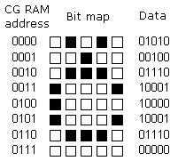
FIG. 4.14 DISPLAY
Before we access DD RAM after defining a special character, the program must set the DD RAM address. Writing and reading data from any LCD memory is done from the last address which was set up using set-address instruction. Once the address of DD RAM is set, a new written character will be displayed at the appropriate place on the screen. Until now we discussed the operation of writing and reading to an LCD as if it were an ordinary memory. But this is not so. The LCD controller needs 40 to 120 microseconds (us) for writing and reading. Other operations can take up to 5 mS. during that time, the microcontroller cannot access the LCD, and so a program needs to know when the LCD is busy. We can solve this in two ways.

One way is to check the BUSY bit found on data line D7. This is not the best method because LCD's can get stuck, and program will then stay forever in a loop checking the BUSY bit. The other way is to introduce a delay in the program. The delay has to be long enough for the LCD to finish the operation in process. Instructions for writing to and reading from an LCD memory shown in the previous table. At the beginning we mentioned that we needed 11 I/O lines to communicate with an LCD. However, we can communicate with an LCD through a 8-bit data bus. The wiring for connection via a 8-bit data bus is shown in the diagram below. In this example we use an LCD display with 2x16 characters, labeled LM16X212 by Japanese maker SHARP.
Pin No. | Name | Description
Pin no. 1 | VSS | Power supply (GND)
Pin no. 2 | VCC | Power supply (+5V)
Pin no. 3 | VEE | Contrast adjust
Pin no. 4 | RS | 0 = Instruction input  1 = Data input
Pin no. 5 | R/W | 0 = Write to LCD module  1 = Read from LCD module
Pin no. 6 | EN | Enable signal
Pin no. 7 | D0 | Data bus line 0 (LSB)
Pin no. 8 | D1 | Data bus line 1
Pin no. 9 | D2 | Data bus line 2
Pin no. 10 | D3 | Data bus line 3
Pin no. 11 | D4 | Data bus line 4
Pin no. 12 | D5 | Data bus line 5
Pin no. 13 | D6 | Data bus line 6
Pin no. 14 | D7 | Data bus line 7 (MSB)

FIG 4.15 PIN CONFIGURATION OF LCD
4.5 BLUETOOTH MODULE

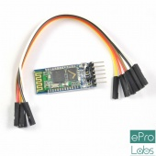
FIG 4.16 BLUETOOTH HC-05 MODULE
4.5.1) INTRODUCTION
HC‐05 module is an easy to use Bluetooth SPP (Serial Port Protocol) module,designed for transparent wireless serial connection setup.The HC-05 Bluetooth Module can be used in a Master or Slave configuration, making it a great solution for wireless communication. This serial port bluetooth module is fully qualified Bluetooth V2.0+EDR (Enhanced Data Rate) 3Mbps Modulation with complete 2.4GHz radio transceiver and baseband. It uses CSR Bluecore 04‐External single chip Rluetooth system with CMOS technology and with AFH (Adaptive Frequency Hopping Feature).
The Bluetooth module HC-05 is a MASTER/SLAVE module. By default the factory setting is SLAVE. The Role of the module (Master or Slave) can be configured only by AT COMMANDS. The slave modules cannot initiate a connection to another Bluetooth device, but can accept connections. Master module can initiate a connection to other devices. The user can use it simply for a serial port replacement to establish connection between MCU and GPS, PC to your embedded project, etc.

4.5.2) HARDWARE FEATURES
- Typical ‐80dBm sensitivity.
- Up to +4dBm RF transmit power.
- 3.3 to 5 V I/O.
- PIO(Programmable Input/Output) control.
- UART interface with programmable baud rate.
- With integrated antenna.
- With edge connector.

5.5.3) SOFTWARE FEATURES
- Slave default Baud rate: 9600, Data bits:8, Stop bit:1,Parity:No parity.
- Auto‐connect to the last device on power as default.
- Permit pairing device to connect as default.

4.5.4) PIN DESCRIPTION
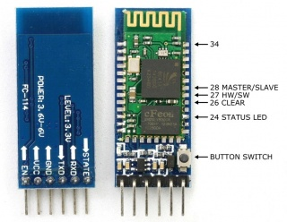
FIG 4.17 PIN CONFIGURATION OF BLUETOOTH MODULE
The HC-05 Bluetooth Module has 6 pins as shown in figure 4.17. They are as follows:
1) ENABLE:

When enable is pulled LOW, the module is disabled which means the module will not turn on and it fails to communicate. When enable is left open or connected to 3.3V, the module is enabled i.e the module remains on and communication also takes place.

2) Vcc: Supply Voltage 3.3V to 5V

3) GND: Ground pin

4) TXD & RXD: These two pins acts as an UART interface for communication

5) STATE:

It acts as a status indicator. When the module is not connected to / paired with any other bluetooth device, signal goes Low. At this low state, the led flashes continuously which denotes that the module is not paired with other device. When this module is connected to/paired with any other bluetooth device, the signal goes High. At this high state, the led blinks with a constant delay say for example 2s delay which indicates that the module is paired.

6) BUTTON SWITCH:

This is used to switch the module into AT command mode. To enable AT command mode, press the button switch for a second. With the help of AT commands, the user can change the parameters of this module but only when the module is not paired with any other BT device. If the module is connected to any other Bluetooth device, it starts to communicate with that device and fails to work in AT command mode.

4.5.5) HOW TO CONNECT BLUETOOTH MODULE

Hardware and software required are :
          - Bluetooth module
          - Microcontroller

1) HARDWARE CONNECTIONS
As we know that Vcc and Gnd of the module goes to Vcc and Gnd of microcontroller.The TXD pin goes to RXD pin of microcontroller and RXD pin goes to TXD pin of microcontroller i.e(digital pin 0 and 1).The user can use the on board Led.But here,Led is connected to digital pin 12 externally for betterment of the process.
2) PROGRAM FOR BLUETOOTH MODULE
The program given below is the HC-05 bluetooth module program. This process is quite different from others since we are going to use android mobile to control and communicate with microcontroller.Here the bluetooth module acts as an interface between our mobile and microcontroller board. Before getting into the execution process,follow the given procedure:
- First of all, the user should install an application called Bluetooth SPP PRO from the playstore which is a free application.
- After installation, pair the bluetooth module to your mobile as like connecting one device to other using bluetooth.The default pairing code is 1234.
- Upload the given program to the microcontroller board.After uploading the code,unplug the USB from the microcontroller.
- Now use external power adapter to power the board.
- The Bluetooth SPP PRO has three types of communication mode.Here Byte stream mode is used to communicate.So select that mode and give the input as 1,as soon as the input has given the led will turn on and for 0 led will turn off.
#include <SoftwareSerial.h>
SoftwareSerial mySerial(0, 1);
int ledpin=12;
int Data;
void setup()
{
mySerial.begin(9600);
pinMode(ledpin,OUTPUT);
}
void loop()
{
if (mySerial.available())
{
Data=mySerial.read();
if(Data=='1')
{
digitalWrite(ledpin,HIGH);
mySerial.println("LED On! ");
}
else if (Data=='0')
{
digitalWrite(ledpin,LOW);
mySerial.println("LED Off! ");
}
}

CHAPTER 5- TECHNOLOGY AND SOFTWARE USED
1) BLUETOOTH TECHNOLOGY
2) KIEL
3) EMBEDDED C
4) SERIAL COMMUNICATION
5.1) BLUETOOTH TECHNOLOGY
Bluetooth is a specification for Wireless Personal Area. It is a way to connect and exchange information and data between mobile phones, laptops, digital cameras and video games. The communication is wireless and has the range of up to 10 meters. The Bluetooth can connect with another Bluetooth. The data need not be carried on a CD or any other way it can be transferred by using a wireless method.The Bluetooth enables to surf the net or check the emails on phones as travel. It is good for people who are always on the move and would like to keep checking their emails.Bluetooth will also enables to transfer files, photos, and songs from the mobile to other device. The Bluetooth comes in with a wireless headsets and it comes in free with the mobile phone or computer, the wireless headset also useful for people who like to be on the go or while driving the car, as they are hands free.The Bluetooth can be attached to GPS system for navigation on mobile phones or laptops for making travel easy.

5.1.1) SOME OF THE COMMON BLUETOOTH PRODUCTS

Now-a-days Bluetooth technology has become the standard when talking about connecting various devices with each other, allowing tasks like data transfer to successfully work out, wirelessly. Poetically named after King Harald Bluetooth of Denmark and Norway, Bluetooth technology unites all sorts of products through the utilization of low power radio signals, on a 2.45 gigahertz frequency, which is actually between 2.402 gigahertz and 2.480 gigahertz radio frequency band. King Harald, whose reign came in the late tenth century, is quite famous for uniting the warring tribes of Denmark during his time as King, defining the poetic nature of the Bluetooth. .
With the ever rising popularity of Bluetooth technology, caused by its impressive universality as a means for devices to connect with each other and its wireless nature, it really isn’t a wonder why many Bluetooth products abound the electronic device market. These Bluetooth products could be easily defined as the wireless class of the hands free kits, which comes in packaged with most mobile phone brands. Hands free kits for mobile phones allow mobile phone users to take calls without having to physically put the phone to ones ear, giving users the ability to do other things while talking. As with all Bluetooth products, Bluetooth Headsets for Mobile Phones are wireless and could be easily connected with ones bluetooth enabled mobile phone, easy as one, two and three. This selfsame wireless nature makes Bluetooth Headsets for mobile phones convenient hands free kits, outperforming them in this aspect. Bluetooth Headsets for Mobile Phones are among the most popular of bluetooth products simply because they are great accessories to have, complementary to Mobile phones, which are items most persons have, these days. And they are wireless too.As Bluetooth products, Bluetooth Dongles or Bluetooth Adapters give personal computers which dont come with integrated Bluetooth capabilities the chance to connect with other Bluetooth items. They are basically Bluetooth products which work in conjunction with a computer program, giving non-Bluetooth computers the avenue for Bluetooth connections.
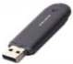

FIG 5.1 BLUETOOTH DONGLE
Because of their appearance, as shown in figure 6.1 Bluetooth Dongles or Bluetooth Adapters are often mistaken for USB Portable Flash Disks, which are basically popular portable storage devices used by many. They do not, in any way, work as Flash Disks, but rather boast same physical appearance as items.

5.1.2) HOW BLUETOOTH WORKS?
Bluetooth devices will normally operate at 2.4 GHZ in the license free, globally available Industrial Scientific and Medical (ISM) radio band. The advantage to this band includes worldwide availability and compatibility. A disadvantage to this however, is that the devices must share this band with other RF emitters. This includes automobile security systems, other wireless devices, and other noise sources, such as microwaves.
To overcome this challenge, Bluetooth employs a fast frequency hopping scheme and therefore uses shorter packets than other standards within the ISM band. This scheme helps to make Bluetooth communication more robust and more secure.
5.1.3) FREQUENCY CHOPPING
Frequency hopping is basically jumping from frequency to frequency within the ISM radio band after a Bluetooth device sends or receives a packet, and the devices (or devices) it’s communicating with hop to another frequency before the next packet is sent.
This scheme offers three advantages

1. Allows Bluetooth devices to use the entirety of the available ISM band, while never transmitting from a fixed frequency for more than a short period of time. This helps insure that Bluetooth conforms to the ISM restrictions on the transmission quantity per frequency.
2. Ensures that any interference won't last long. Any packet that doesn't arrive safely to its destination can be resent to the next frequency.
3. Provides a base level security as it's very hard for an eavesdropping device to predict which frequency the Bluetooth devices use next.
The connected devices however, must agree upon the frequency they will use next. The specification in Bluetooth ensures this in two ways. First, it defines a master and slave type relationship between Bluetooth devices. Next, it specifies an algorithm that uses device specific information when calculating the frequency hop sequences. A Bluetooth device that operates in master mode can communicate with up to seven devices that are set in slave mode. To each of the slaves, the master Bluetooth device will send its own unique address and the value of its own internal clock. The information sent is then used to calculate the frequency hop sequences.Because the master device and each of the slave devices use the same algorithm with the same initial input, the connected devices will always arrive together at the next frequency that they have agreed upon.As a replacement for cable technology, it's no wonder that Bluetooth devices are usually battery powered, such as wireless mice and battery powered cell phones. To conserve the power, most devices operate in low power. This helps to give Bluetooth devices a range of around 5 - 10 meters.This range is far enough for wireless communication but close enough to avoid drawing too much power from the power source of the device.
5.1.4) TECHNICAL OF BLUETOOTH TECHNOLOGY
Bluetooth wireless technology is an open specification for a wireless personal area network (PAN). It provides limited range wireless connectivity for voice and data transmissions between information appliances. Bluetooth wireless technology eliminates the need for interconnecting cables. Unique for most wireless communications systems, Bluetooth enables ad hoc networking among devices, without the need for infrastructure such as base stations or access points.
Bluetooth, in its most elementary form, is defined as a global specification for wireless connectivity. Because it is intended to replace cables, cost must be low and operation must be intuitive and robust. These requirements for Bluetooth create many challenges. Bluetooth meets these challenges by several means. The radio unit employs frequency hopping spread spectrum (FHSS), and the design emphasis is on very low power, extremely low cost, and robust operation in the uncoordinated, interference-dominated RF environment of the industrial, scientific, and medical (ISM) radio band.A wide variety of Bluetooth radio block diagrams are in use. For transmission, these range from direct voltage controlled oscillator (VCO) modulation to IQ mixing at the final radio frequency (RF.) In the receiver, a conventional frequency discriminator or IQ down-conversion combined with analog-to-digital conversion is noted. While many options can satisfy the Bluetooth radio specifications, each will have its own characteristics if not operating correctly. The Bluetooth system consists of a radio unit, a baseband link control unit, and link management software. It also includes higher-level software utilities that focus on interoperability features and functionality.
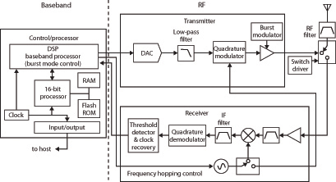
FIGS 5.2 BLOCK DIAGRAM OF FREQUENCY HOPPING SYSTEM
The above Figure 5.2 is a block diagram for this type of frequency hopping system, showing the baseband controller and the RF transmitter and receiver sections. EDR is an enhancement to the Bluetooth 1.2 standard and is described in the Bluetooth 2.0 specification. It is backward compatible with the earlier Bluetooth standards. It uses a phase shift keying (PSK) modulation scheme to achieve a data rate of 2 or 3 Mb/s. It allows greater possibilities for using multiple devices on the same connection because of the increased bandwidth. Due to EDR having a reduced duty cycle, there is lower power consumption compared to a standard Bluetooth link.
5.1.5) ADVANTAGES OF BLUETOOTH DEVICES.
- Bluetooth Devices are Wireless.
In addition to improving safety as a result of eliminating the clutter of wires and associated hazardous connections, wireless technology also offers many convenient advantages. For example, when traveling with the laptop, PDA, MP3 player and other devices, there is no worry about bringing along all of connecting cables.

2. Bluetooth Technology is Inexpensive.
Bluetooth technology is cheap for companies to implement, which results in lower over-all manufacturing costs. These savings are then passed on to the consumer. The end result is Bluetooth devices are relatively inexpensive.
3. Bluetooth is Automatic.
Bluetooth doesn’t think about setting up a connection or to push any buttons. When two or more Bluetooth devices enter a range (Up to 30 feet) of one another, they automatically begin to communicate without having to do anything. Once the communication begins, Bluetooth devices will setup Personal Area Networks or Piconets.
4. Standardized Protocol / Interoperability
Since Bluetooth is a standardized wireless specification, a high level of compatibility among devices is guaranteed. The Bluetooth specification uses and defines various profiles. Every Bluetooth profile is specific to a particular function. For instance, when a Bluetooth enabled cell phone and a Bluetooth headset (Both with the same profile) are communicating with one another, both will understand each other without the user having to do anything, even if the devices are of different models/makes.
5. Low Interference
Bluetooth devices avoid interference with other wireless devices by:
a) Using a technique known as spread-spectrum frequency hopping.
b) Using low power wireless signals.

6. Low Energy Consumption
Bluetooth uses low power signals. As a result, the technology requires little energy and will therefore use less battery or electrical power. Obviously, this is a great benefit for mobile devices because Bluetooth won't drain the life of device's battery.
7. Share Voice and Data
The Bluetooth standard allows compatible devices to share both voice and data communications. For example, it is probably no surprise that a Bluetooth enabled cell phone is capable of sharing voice communications with a compatible Bluetooth headset. Then, using Bluetooth the phone can connect to a laptop. At the end the laptop is capable of surfing the web or sending and receiving email.
8. Instant Personal Area Network (PAN)
Up to seven compatible Bluetooth devices can connect to one another within approximate of up to 30 feet, forming a PAN or piconet. Multiple piconets can be automatically setup for a single room.
9. Upgradeable
The Bluetooth standard is upgradeable. A development group at the Bluetooth Special Interest Group (SIG) has been given the task of working on the new Bluetooth version 2, which offers several new advantages and is backward compatible with the older versions.
5.2) INTRODUCTION TO KIEL MICROVISION (IDE)
Kiel an ARM Company makes C compilers, macro assemblers, real-time kernels, debuggers, simulators, integrated environments, evaluation boards, and emulators for ARM7/ARM9/Cortex-M3, XC16x/C16x/ST10, 251, and 8051 MCU families.Keil development tools for the 8051 Microcontroller Architecture support every level of software developer from the professional applications engineer to the student just learning about embedded software development. When starting a new project, simply select the microcontroller you use from the Device Database and the µVision IDE sets all compiler, assembler, linker, and memory options for you. Keil is a cross compiler. So first we have to understand the concept of compilers and cross compilers. After then we shall learn how to work with keil.

5.2.1) CONCEPT OF COMPILER

Compilers are programs used to convert a High Level Language to object code. Desktop compilers produce an output object code for the underlying microprocessor, but not for other microprocessors. I.E the programs written in one of the HLL like ‘C’ will compile the code to run on the system for a particular processor like x86 (underlying microprocessor in the computer). For example compilers for Dos platform is different from the Compilers for Unix platform So if one wants to define a compiler then compiler is a program that translates source code into object code.

The compiler derives its name from the way it works, looking at the entire piece of source code and collecting and reorganizing the instruction. See there is a bit little difference between compiler and an interpreter. Interpreter just interprets whole program at a time while compiler analyses and execute each line of source code in succession, without looking at the entire program.The advantage of interpreters is that they can execute a program immediately. Secondly programs produced by compilers run much faster than the same programs executed by an interpreter. However compilers require some time before an executable program emerges. Now as compilers translate source code into object code, which is unique for each type of computer, many compilers are available for the same language.

5.2.2) CONCEPT OF CROSS COMPILER

A cross compiler is similar to the compilers but we write a program for the target processor (like 8051 and its derivatives) on the host processors (like computer of x86). It means being in one environment you are writing a code for another environment is called cross development. And the compiler used for cross development is called cross compiler. So the definition of cross compiler is a compiler that runs on one computer but produces object code for a different type of computer.

5.2.3) KEIL C CROSS COMPILER

Keil is a German based Software development company. It provides several development tools like
- IDE (Integrated Development environment)
- Project Manager
- Simulator
- Debugger
- C Cross Compiler, Cross Assembler, Locator/Linker

The Keil ARM tool kit includes three main tools, assembler, compiler and linker. An assembler is used to assemble the ARM assembly program. A compiler is used to compile the C source code into an object file. A linker is used to create an absolute object module suitable for our in-circuit emulator.

5.2.4) BUILDING AN APPLICATION IN µVision2
To build (compile, assemble, and link) an application in µVision2, you must:
- Select Project -(forexample,166\EXAMPLES\HELLO\HELLO.UV2).
- Select Project - Rebuild all target files or Build target.µVision2 compiles, assembles, and links the files in your project.

5.2.5) CREATE YOUR OWN APPLICATION IN µVision2

To create a new project in µVision2, you must:
- Select Project - New Project.
- Select a directory and enter the name of the project file.
- Select Project - Select Device and select an 8051, 251, or C16x/ST10 device from the Device Database™.
- Create source files to add to the project.
- Select Project - Targets, Groups, Files. Add/Files, select Source Group1, and add the source files to the project.
- Select Project - Options and set the tool options. Note when you select the target device from the Device Database all special options are set automatically. You typically only need to configure the memory map of your target hardware. Default memory model settings are optimal for most applications.
- Select Project - Rebuild all target files or Build target.

5.2.6) DEBUGGING AN APPLICATION IN µVision2
To debug an application created using µVision2, you must:
- Select Debug - Start/Stop Debug Session.
- Use the Step toolbar buttons to single-step through your program. You may enter G, main in the Output Window to execute to the main C function.
- Open the Serial Window using the Serial #1 button on the toolbar.
Debug your program using standard options like Step, Go, Break, and so on.

µVision2 is a standard Windows application and started by clicking on the program icon. To create a new project file select from the µVision2 menu Project – New Project…. This opens a standard Windows dialog that asks you for the new project file name. We suggest that you use a separate folder for each project. You can simply use the icon Create New Folder in this dialog to get a new empty folder. Then select this folder and enter the file name for the new project, i.e. Project1. µVision2 creates a new project file with the name PROJECT1.UV2 which contains a default target and file group name. You can see these names in the Project.

Now use from the menu Project – Select Device for Target and select a CPU for your project. The Select Device dialog box shows the µVision2 device data base. Just select the microcontroller you use. We are using for our examples the Philips 80C51RD+ CPU. This selection sets necessary tool Options for the 80C51RD+ device and simplifies in this way the tool Configuration.

5.2.7) BUILDING PROJECTS AND CREATING HEX FILES

Typical, the tool settings under Options – Target are all you need to start a new application. You may translate all source files and line the application with a click on the Build Target toolbar icon. When you build an application with syntax errors, µVision2 will display errors and warning messages in the Output Window – Build page. A double click on a message line opens the source file on the correct location in a µVision2 editor window. Once you have successfully generated your application you can start debugging. After you have tested your application, it is required to create an Intel HEX file to download the software into an EPROM programmer or simulator. µVision2 creates HEX files with each build process when Create HEX files under Options for Target – Output is enabled. You may start your PROM programming utility after the make process when you specify the program under the option Run User Program #1.

5.2.8) CPU SIMULATION

µVision2 simulates up to 16 Mbytes of memory from which areas can be mapped for read, write, or code execution access. The µVision2 simulator traps and reports illegal memory accesses. In addition to memory mapping, the simulator also provides support for the integrated peripherals of the various 8051 derivatives. The on-chip peripherals of the CPU you have selected are configured from the Device.
5.2.9) DATABASE SELECTION

You have made when you create your project target. Refer to page 58 for more Information about selecting a device. You may select and display the on-chip peripheral components using the Debug menu. You can also change the aspects of each peripheral using the controls in the dialog boxes.

5.2.10) START DEBUGGING

You start the debug mode of µVision2 with the Debug – Start/Stop Debug Session Command. Depending on the Options for Target – Debug Configuration, µVision2 will load the application program and run the startup code µVision2 saves the editor screen layout and restores the screen layout of the last debug session. If the program execution stops, µVision2 opens an editor window with the source text or shows CPU instructions in the disassembly window. The next executable statement is marked with a yellow arrow. During debugging, most editor features are still available.
5.2.11) DISASSEMEBLY WINDOW

The Disassembly window shows your target program as mixed source and assembly program or just assembly code. A trace history of previously executed instructions may be displayed with Debug – View Trace Records. To enable the trace history, set Debug – Enable/Disable Trace Recording. If you select the Disassembly Window as the active window all program step commands work on CPU instruction level rather than program source lines. You can select a text line and set or modify code breakpoints using toolbar buttons or the context menu commands.

You may use the dialog Debug – Inline Assembly… to modify the CPU instructions. That allows you to correct mistakes or to make temporary changes to the target program you are debugging. Numerous example programs are included to help you get started with the most popular embedded 8051 devices.

The Keil µVision Debugger accurately simulates on-chip peripherals (I²C, CAN, UART, SPI, Interrupts, I/O Ports, A/D Converter, D/A Converter, and PWM Modules) of your 8051 device. Simulation helps you understand hardware configurations and avoids time wasted on setup problems. Additionally, with simulation, you can write and test applications before target hardware is available.

5.3) EMBEDDED C

Use of embedded processors in passenger cars, mobile phones, medical equipment, aerospace systems and defense systems is widespread, and even everyday domestic appliances such as dish washers, televisions, washing machines and video recorders now include at least one such device.

Because most embedded projects have severe cost constraints, they tend to use low-cost processors like the 8051 family of devices considered in this book. These popular chips have very limited resources available most such devices have around 256 bytes (not megabytes!) of RAM, and the available processor power is around 1000 times less than that of a desktop processor. As a result, developing embedded software presents significant new challenges, even for experienced desktop programmers. If you have some programming experience - in C, C++ or Java - then this book and its accompanying CD will help make your move to the embedded world as quick and painless as possible.

5.4) SERIAL COMMUNICATION
The concept of serial communication is simple, in serial communication data is sent one bit at a time. Serial communication requires only one line for the data; second line for ground & possible a third line for clock. Although this is slower than parallel communication, which allows the transmission of an entire byte at once, it is simpler & requires less physical wires for communication so can be used over longer distances.
IEEE 488 specifications for parallel communication state that the cabling between equipment can be no more than 20 meters total, with no more than 2 meters between any two devices; serial, however, can extend as much as 1200 meters.
Synchronous and asynchronous transmissions are two different methods of transmission. In Synchronous transmission the transmitter & receiver are synchronized through external clock, while in asynchronous transmission the transmitter & receiver are synchronized by special signals along the transmission medium.

5.4.1) SYNCHRONOUS TRANSMISSION
Figure 5.3 shows the block diagram of Synchronous transmission. As you can see a common clock line is required between the transmitter & receiver.
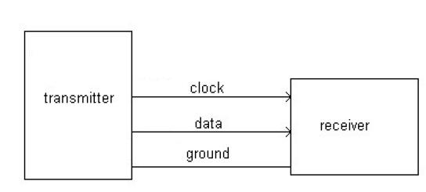
FIG5.3 SYNCHRONOUS TRANSMISSION

5.4.2) ASYNCHRONOUS TRANSMISSION
In asynchronous transmission since the transmitter & receiver are synchronized by special signals along the transmission medium there is no need of the clock signal. Asynchronous transmissions is advantageous over long distance, moreover it is easy to set up & well suited for application where messages are generated at irregular intervals. There is no clock pulse so the receiver must know at what rate the data is transmitted (Baud Rate). It should also know the number of bits per word (DATA BITS) the transmitter is using as well as it should know when the data begins (START BIT) & where the data stops (STOP BIT).All the above parameter make up the PROTOCOL. If the receiver & transmitters protocol is the same then receiver will receive the correct data.

5.4.3) BAUD RATE
It indicates the number of bits transferred per second. So when we say 9600 BAUD RATE it means 9600 BITS per second.
5.4.4) DATA BITS
It indicates the number of bits in a Transmission WORD. In asynchronous communication other that the data which is normally 8-bit at least two more bits i.e. START bit & STOP bits are transmitted. So the actual number of bits transmitted is ten.

5.4.5) START and STOP BITS
The receiver should know when the data transmission has started; this is indicated by the START BIT. In most protocols the start bit is LOGIC 0. So when no data is being transmitted the data line is HIGH. And the receiver waits for the 1 to 0 transition & once this transition occurs the receiver knows that the data is being transmitted.
The receiver knows the baud rate as well as the number of bits to be received i.e. eight so it reads the eight bits after the start bit & then checks if the next bit is a STOP BIT which is basically a LOGIC 1. If the last bit is not LOGIC 1 then it assumes error in communication & then dumps the data.
5.4.6) RS 232 STANDARD
RS232 is a most basic & the oldest form of UART. It is basically used for POINT TO POINT Communication. Since transmit & receive lines are different it can operate in full duplex mode. The RS 232 standard defines different voltage level corresponding to Logic 1 & Logic 0. Logic 1 is defined as negative voltage & Logic 0 is defined as positive voltage. Valid voltages are in range of plus or minus 3 to 15 Volts for Logic 0 & Logic 1 correspondingly. Since the voltage level is higher than the used in the digital circuit’s special driver circuit are required to convert the logic levels.
CHAPTER 6- CODE FOR MICROCONTROLLER
#include<reg51.h>
#include<lcd.h>
#include<ser.h>
#include<string.h>

bit run=1;
unsigned char str[12],cnt;
unsigned char key[4],dat;
void ser() interrupt 4
{
if(RI)
{
EA=0;//disable interrupt
while(RI==0);
for(cnt=0;cnt<12;cnt++)
str[cnt]=ser_rcv();
run=0;
}
}
void main()
{
IE=0x90; //interrupt enable ser comm
lcdinit();//initialise the lcd
ser_init();//initialise the ser comm
lcddis("Smart E-CART");
lcdcmd(0xc0);
lcddis("Enter Product");

while(1)
{
EA=1;//enable interrupt
if(run==0)
{
run=1;
lcddis(" WELCOME ");
lcdcmd(0xc0);//for 2nd line
if(!strncmp(str,"5000D7ED1872",12))//
{
delay(50);
lcddis("Product 1 ");
ser_str("Product1");
}
if(!strncmp(str,"5000D7ED5339",12))
{
delay(50);
lcddis("Product2 ");
ser_str("Product 2");
}
if(!strncmp(str,"5000D7E52F4D",12))
{ delay(50);
lcddis("Product3 ");
ser_str("Product3");
}

if(!strncmp(str,"5000D7E57113",12))
{
delay(50);
lcddis("Product4 ");
ser_str("Product4");
}
if(!strncmp(str,"5000D7E50361",12))

{
delay(50);
lcddis("Product5 ");
ser_str("Product5");}}}}

CHAPTER 7- HARDWARE TESTING

7.1) CONTINUITY TEST:
In electronics, a continuity test is the checking of an electric circuit to see if current flows (that it is in fact a complete circuit). A continuity test is performed by placing a small voltage (wired in series with an LED or noise-producing component such as a piezoelectric speaker) across the chosen path. If electron flow is inhibited by broken conductors, damaged components, or excessive resistance, the circuit is "open".Devices that can be used to perform continuity tests include multi meters which measure current and specialized continuity testers which are cheaper, more basic devices, generally with a simple light bulb that lights up when current flows.An important application is the continuity test of a bundle of wires so as to find the two ends belonging to a particular one of these wires; there will be a negligible resistance between the "right" ends, and only between the "right" ends.

This test is the performed just after the hardware soldering and configuration has been completed. This test aims at finding any electrical open paths in the circuit after the soldering. Many a times, the electrical continuity in the circuit is lost due to improper soldering, wrong and rough handling of the PCB, improper usage of the soldering iron, component failures and presence of bugs in the circuit diagram. We use a multi meter to perform this test. We keep the multi meter in buzzer mode and connect the ground terminal of the multi meter to the ground. We connect both the terminals across the path that needs to be checked. If there is continuation then you will hear the beep sound.

7.2) POWER ON TEST:
This test is performed to check whether the voltage at different terminals is according to the requirement or not. We take a multi meter and put it in voltage mode. Remember that this test is performed without microcontroller. Firstly, we check the output of the transformer, whether we get the required 12 v AC voltage.
Then we apply this voltage to the power supply circuit. Note that we do this test without microcontroller because if there is any excessive voltage, this may lead to damaging the controller. We check for the input to the voltage regulator i.e., are we getting an input of 12v and an output of 5v. This 5v output is given to the microcontrollers’ 40th pin. Hence we check for the voltage level at 40th pin. Similarly, we check for the other terminals for the required voltage. In this way we can assure that the voltage at all the terminals is as per the requirement.

CHAPTER 8- CONCLUSION AND FUTURE SCOPES
8.1 CONCLUSION
In this project we conclude that with the use of simple available, technologies, we could design an e cart that could help us to save a lot of time. Even by little more advancement it will be used directly for any type of e payment. It helps in cashless transaction which will save tree. As well cashless transaction makes accountable money more in comparison to cash transaction. A simple application by the seller will be provided to regular customers that will save time directly. An automated bill will be generated and will be displayed on the customers mobile phone. Just by a single click the app is connected to the payment portal and bill will be paid by transaction of cash through bank account to account. By which corruption and black money will be reduced.
8.2 FUTURE SCOPES

The desired goals were auspiciously achieved in the prototype model developed. The developed product is easy and simple to use and less expensive. Even if the project displays the proof of concept, there are a few features that can be compressed to make a smarter shopping cart more powerful. In this project, the response time of the wireless communication with the server is to be considered. Then, the communication is not that much more secure. It is impracticable to hold RFID tag to some products. In such cases, traditional scanning method using barcode is more complicated. In forward, a more complex microcontroller and larger display system can be put up to provide an improved user experience. In future, the transaction and bill payment can be linked to a bank account of each customer by adding the functionalities in the mobile app.

REFERENCE
[1] Dr. Suryaprasad J, Praveen Kumar B O, Roopa D & Arjun A K "A Novel Low-Cost Intelligent Shopping Cart", 2014 IEEE.
[2] Amine Karmouche, Yassine Salih-Alj, "Aisle-level Scanning for Pervasive RFID-based Shopping Applications", 2013 IEEE.
[3]. Raju Kumar, K. Gopalakrishna, K. Ramesha “Intelligent Shopping Cart” International Journal Of Engineering Science And Innovative Technology (IJESIT) Volume 2, Issue 4, July 2013.
[4]Satish Kamble, Sachin Meshram, Rahul Thokal & Roshan Gakre, "Developing a Multitasking Shopping Trolley based on RFID Technology", January 2014 International Journal of Soft Computing and Engineering (IJSCE).
[5]. Ms. RupaliSawant, Kripa Krishnan, ShwetaBhokre, PriyankaBhosale “The RFID Based Smart Shopping Cart” International Journal Of Engineering Research And General Science, Volume 3, Issue 2, MarchApril, 2015 ISSN 2091-2730.
[6]. R. Rajeshkumar, R. Mohanraj, M. Varatharaj “Automatic Barcode Based Bill Calculation By Using Smart Trolley” International Journal Of Engineering Science And Computing, March 2016

